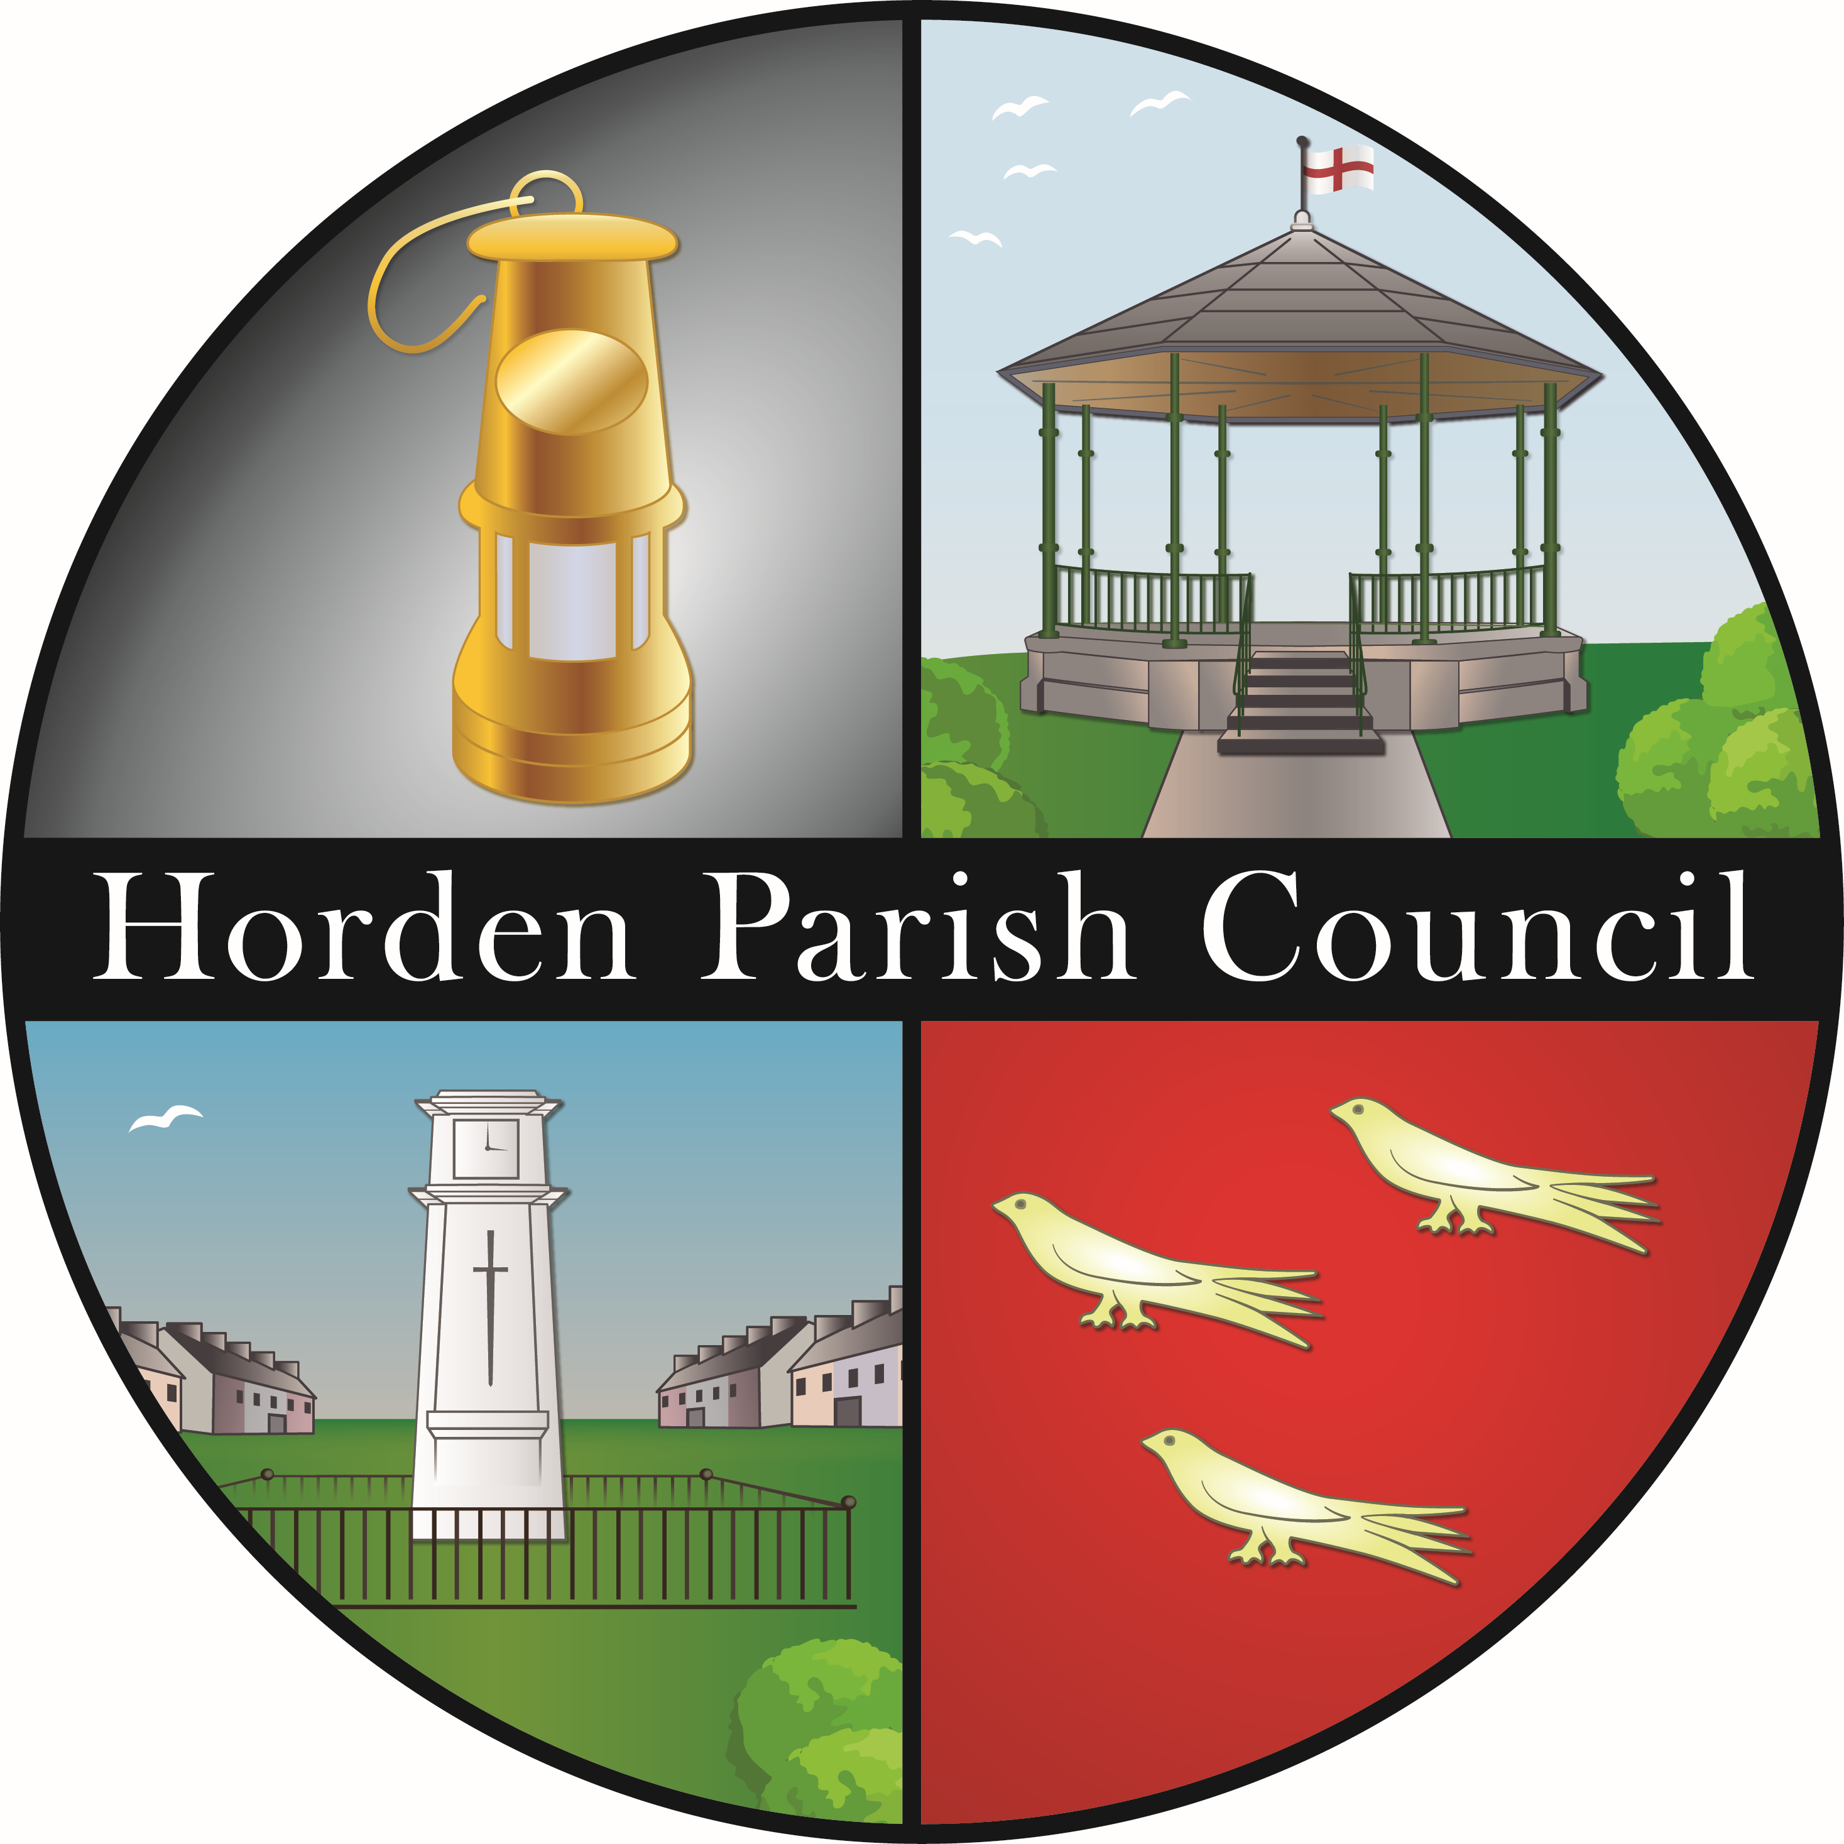
Contents Page

Horden Parish Council Annual Report 2025/26

Message from the Chairman 3
About Us 4
Introduction 4

Review of 2025/26
Welfare Park 5
Memorial Park 5
Cotsford Park 6
Church Green 6
Maritime Crescent 6
Sunderland Road Playing Fields 6
Thorpe Road Cemetery 6
Station Road Allotments 7
Social Welfare Centre 7
Finance 7
Grant Funding 7
Publicity & Communications 7
Planning Applications 7
Members Attendance at 2025/26 Meetings 8
Members Claims 2025/26 8

Message from the chairman……
I was proud to be elected by my fellow councillors as Chairman for 2025/2026
As it was an election year, we said goodbye to Councillor Paula Wood and welcomed Councillors Tony Usher and Dawn Bellingham.
This year has been an extra special year as we celebrated Horden’s 125th Anniversary.

The Council facilitated a Working Group which was represented with local community groups and businesses to create a wide variety of activities. These included: Flower and Vegetable Show, Heritage Display, a Play about mining by Ensemble ’84, Service of Thanksgiving, Mural Unveil and Street Party, plus many more.

To conclude the two weeks of celebrations the Parish held an event in the Recreation ground, which included fairground rides and a musical band singing local songs. The event was opened by the Lord Lieutenant Sue Snowdon.

In all a wonderful and fitting celebration for the village, filled with pride for the past and optimism for the future.
In December we held the annual Christmas Tree Lighting Service where we worked again with Creative Youth Opportunities on a lantern parade, the Salvation Army band and Fr Kyle McNeil who led the carol service.
We also held family activities during the school holiday periods.
I was proud to provide financial support to local community groups including Coalfields Regeneration Trust, Salvation Army, Horden Bowls Club and Horden Heritage Centre and Vintage Tea Rooms.
I would like to thank all members and staff of the council for their support during the year. I would particularly like to thank Samantha Shippen who retired as Clerk at the end of the year, we thank her for her dedication to the Parish. As a team we work with commitment to the council and to serve the residents of Horden.
Cllr Frank Leadbitter
Chairman of The Council 2025/2026

L-R: Remembrance Day: Flower and Vegetable Show; 125th Anniversary Flag winner

about us
Horden Parish Council is made up of 15 Councillors and usually meets the first Thursday of every month, with the exception of August. In January we move to the second Thursday.
Your 2025/26 councillors are:
Cllr Rodie Bagnall Vice-Chairman Horden Parish Council
Cllr Thomas Baldasera Vice-Chairman of Horden Recreation Ground
Cllr Dawn Bellingham
Cllr Chris Cain
Cllr Eileen Laing
Cllr Frank Leadbitter Chairman of Horden Parish Council
Cllr Cheryl Robson
Cllr William Morrow
Cllr William Smith
Cllr David Tait
Cllr Tony Usher
Cllr Jackie Ward
Cllr Graeme Wetherell
Cllr Laurence Williams
Cllr Francis Winrow Chairman of Horden Recreation Ground

The Parish Council employed the following staff:
Samantha Shippen Clerk to the Council & RFO
Colin Jackson Deputy Clerk & Finance Officer
Michelle Hannant Administration and Finance Officer
Brooke Howarth Administration Officer
Angela Lee SWC Operations & Events Manager
John Peace Outdoor Team Manager
Richard Hepworth Outdoor Team Leader
Allan Roberts Gardener / Gravedigger
Joe Hall Gardener / Gravedigger
Kyle Bagnall Gardener / Gravedigger
Callum Lamb Gardener / Gravedigger
Arthur Burton Gardener / Gravedigger (Casual)
Branden Pratt Gardener / Gravedigger (Casual)
Molly Banks Apprentice Gardener / Gravedigger
Sharon Atchinson SWC Cleaner
Vacant SWC Cleaner

INTRODUCTION

Welcome to the 2025/26 Annual Report of the Parish Council. This report has been produced and made available prior to the Annual Assembly to be held on Thursday 28th May 2026 at 6pm in the Social Welfare Centre.

The Annual Assembly is a meeting of the electors of the Parish of Horden and gives an opportunity for any registered elector of the parish to discuss the information provided and to question the Council on its activities during the past year. Any member of the public is welcome to attend this meeting, although only registered electors are able to participate.

Horden Parish Council deliver many services in the village, including the provision of parks, playing fields and recreation areas. The Council also manage Thorpe Road Cemetery and the Social Welfare Centre.

The Council’s aim is to give the residents of Horden information about the Parish Council and the services it delivers in the village, to outline how it deals with current challenges and highlight plans to meet community needs and deliver quality services in the next year and beyond.

Meetings of the Parish Council are normally held on the first Thursday of every month, except August when Council is in recess. Meetings start at 6pm in the Social Welfare Centre. The Agenda for Council meetings is prepared on the Friday prior to the meeting and displayed on the parish notice board in the foyer of the Social Welfare Centre and on its website for the public to view.

All meetings of the Council are open for the public (although certain exempt items may be
held in private session). If you wish to attend a meeting, just turn up. The Council is happy for the public to give their views or comments during Public Participation but ask that you notify the Clerk prior to the meeting of the topic on which you wish to speak.

Minutes of meetings are available for public inspection at the Social Welfare Centre and via our website. Any member of the public is entitled by law to obtain printed copies of the minutes at reasonable cost. These can be obtained from the Parish Council Offices at the Social Welfare Centre.

REVIEW OF 2025/26

Welfare Park (Registered Charity Horden Recreation Ground 520826)

The Council is sole Trustee of the Charity.

A range of events and activities organised within the Welfare Park continue to be popular with the residents of Horden and the surrounding villages. Details of events can be found displayed in park noticeboards, in the window at the Social Welfare Centre and on our Facebook page (Horden Parish Council). In summer 2025 we continued to provide a number of “Summer Holiday” and other events, supported by our partners at Creative Youth Opportunities and of course celebrate our 125th anniversary with a fun packed day of activities for all ages.

A number of local partners and organisations have used the Welfare Park to host their events and activities over the course of 2025/6. HCW Football and Cricket Clubs continue to grow their sports within the park particularly for young people. The Council look forward to continued successful partnership working to provide activities for residents, whilst fully utilising facilities.

Creative Youth Opportunities CIC has now an established presence in the Parish providing youth provision within Park House and at the Social Welfare Centre each week.

The Vintage Tea Room and Heritage Centre, run by volunteers, continues to be a popular attraction in the park. The Tea Room and Heritage Centre are open every Monday, Wednesday and Friday from 10:30am – 3pm in the months of March – October.

This year the Welfare Park welcomed the Junior Park Run which is held every Sunday morning and is proving a huge success!

Parish Council staff have continued to deliver a great service in their upkeep and maintenance of the park and sporting facilities. The dedication and commitment to excellence ensure that users of the Welfare Park continue to enjoy the amenities at the quality they expect. A special thank you therefore must go to the staff for their efforts, we are sure you notice the beautiful shrub and flower beds but also appreciate the relatively litter-free environment.

Memorial Park

2025/26 has been a year of general ongoing maintenance at Memorial Park. The staff continue to achieve excellent standards at the park.

True to village tradition, the annual Remembrance Sunday ceremony and Tree Lighting Service were held in the Park in 2025. The attendance for all these events was once again excellent.

Cotsford Park

The grassed area in the centre of the inner ring of houses on the Cotsford Park Estate is a registered village green for which the Parish Council has management responsibility.

Church Green

Church Green is the area of grass at the bottom of the Memorial Park opposite St Mary’s Church. It provides walkways from Sixth and Seventh Streets to Blackhills Terrace and has a number of seating areas, litter bins and dog bins.

This area was registered by the Parish Council as a village green in 2014, protecting the green from future development.

Maritime Crescent

The grassed play area at Maritime Crescent in Grants Houses is owned by Durham County Council. The play equipment and mini goals are however, the property of Horden Parish Council.

Sunderland Road Playing Fields

A number of football teams continue to use the football pitches at Sunderland Road. If you have a team that would like to use our facilities, you need to book with us, we will then make sure our car parking and changing rooms are available. Any organised use of the facilities requires the Council’s permission.

Whippet racing also takes place on the fields on a Saturday morning and Thursday afternoon, in keeping with the tradition of the village.

The playing fields also cater for more informal activities such as an outdoor gym, five-a-side football, permanent mini goals are provided on the fields alongside a small play area for children.

Thorpe Road Cemetery

During 2025/26 a total of 61 burials took place as follows:
 | Total | Horden | % | Others | %
All Burials | 61 | 44 | 72% | 17 | 28%
Full Burials | 41 | 32 | 78% | 9 | 22%
Ashes | 20 | 12 | 60% | 8 | 40%

In addition to the sixty-one burials, memorial plaques were sold for display on the memorial wall. The Parish Council will consider donations of seats, trees, rose bushes and other items, space permitting.

The cemetery rules of management were revised in 2022 following a public consultation. Families should make themselves familiar with the rules and regulations, details of which are on the Council website.

We make regular inspections of headstones, if any are identified as unstable, they will be laid flat. All rights holders are contacted at the last known address, although the majority of letters get returned as unknown. We remind families that older graves may require the permission to be renewed, at a fee and that we require any change of address to be notified so we can contact you if there are any issues.

A “Letters to Heaven” post-box and a refurbished seat were recently installed at the cemetery. We have secured funding to develop the Teddy Bear SMILES memorial area within the cemetery, with thanks from the Area Action Partnership Neighbourhood Budget.

Station Road Allotments

The allotments are situated at the end of Acacia Avenue and are on both sides of the railway bridge. The land is part owned by the Parish Council and part owned by Castle Eden Estates and the whole site is rented to Station Road Allotment Association who manage the site on our behalf. We are grateful to the Committee for their work.

Social Welfare Centre

The Social Welfare Centre continues to be used by many residents and community groups. Activities include Horden Girl Guides, Horden Residents’ Association, Horden Regeneration Partnership, Andy’s Man Club to name a few.

The Social Welfare Centre continues to provide office space for Durham Deafened Support and Durham County Council - Horden Together who occupy the first floor of the Social Welfare Centre. Horden Together has a team of staff who are supporting vulnerable residents and helping to improve the environment in Horden in both practical ways and using their powers of enforcement where necessary. For further information about the work of Horden Together they can be contacted on 03000 263 387.

Finance

During 2025/26, the Council set a budget of £1,111,220. It is estimated that the Council spent £685,057 during the year. The reason for the difference is that planned capital projects did not go ahead due to staffing changes. Details of the Council Budget can be found on the Council’s website.

Grant Funding
The Parish Council give many grants and donations to local groups and charitable organisations during the year. Some of the grants are in the form of free or reduced rental for the use of Parish Council facilities, particularly the Social Welfare Centre. Other grants are in the form of monetary donations. All requests for grants are considered by the Council, a total of £8,932.95 was granted.
Listed below are the groups and organisations who received financial assistance in 2024/25:
Group/Organisation | Amount |  | Group/Organisation | Amount
Andy's Man Club | £2,683.18 |  | Warm Space | £635.00
CISWO | £1,728.00 |  | Horden Residents Association | £218.75
Creative Youth Opportunities | £1,430.63 |  | Hooked on Crafts | £105.00
Horden Girl Guides | £1,084.97 |  | Horden Minewater | £104.94
Patchwork | £942.48

Publicity & Communications

The Parish Council continued updating our website: https://horden-pc.gov.uk which provides details of meeting dates and times, details of upcoming events and recent publications, there is also a section for agendas and minutes of meetings. The Parish Council also continue to use Facebook and noticeboards as a means of communicating with the local community.

Events and activities organised by the Council are advertised in the noticeboards at the Welfare Park and Social Welfare Centre, on the website and also social media sites.

Planning Applications

The Parish Council is a consultee on all planning applications submitted to Durham County Council for Horden. This means that the Parish Council has the opportunity to support or object to any application submitted from within the village. During 2025/26 there was one application a response was provided by the Parish Council.

Members Attendance at Meetings 2025/26

 | Councillor
Meeting date | Chris Armstrong | Rodie Bagnall | Thomas Baldasera | Dawn Bellingham | Chris Cain | Eileen Laing | Frank Leadbitter | William Morrow | Cheryl Robson | David Tait | Tony Usher | Jackie Ward | Graeme Wetherell | Laurence Williams | Francis Winrow
15/05/25 |  |  |  |  |  |  |  |  |  | Aa
05/06/25 |  |  | Aa |  |  | Aa |  |  |  |  |  |  |  | Aa
03/07/25 |  |  |  |  |  |  |  |  |  | Aa
04/09/25 |  |  |  | Aa |  |  |  |  |  |  |  |  | Aa | Aa | Aa
02/10/25 |  |  |  |  |  |  |  |  |  |  |  |  |  | 0 | Aa
06/11/25 |  |  |  |  |  | 0
04/12/25 |  | 0 |  |  |  |  |  |  | 0 |  |  |  |  | Aa
15/01/26 |  |  |  |  |  |  |  |  |  |  |  |  | Aa | Aa
05/02/26 |  | Aa |  |  | Aa |  |  |  | Aa
05/03/26 |  | Aa |  | Aa |  |  |  |  | Aa | Aa
02/04/26 |  | Aa | Aa |  |  |  |  |  |  | Aa |  |  |  | 0
Key: |  | Attended Meeting |  |  |  |  | 0 | No Apologies Received
Key: | Aa | Apologies Accepted |  |  |  |  | Ar | Apologies Received

Members Allowances and Expenses Claims 2025/26

Listed below for public disclosure is the allowances and other expenses claimed by the Parish Council’s elected Members during the financial year 2025/26.
Surname | Forename | Allowance £ | Total Payment £
Armstrong | Chris | 571.92 | 571.92
Bagnall | Rodie | 571.92 | 571.92
Baldasera | Thomas | No claim | 0.00
Bellingham | Dawn | 571.92 | 571.92
Cain | Chris | 571.92 | 571.92
Laing | Eileen | 571.92 | 571.92
Leadbitter | Francis | 571.92 | 571.92
Morrow | William | Not eligible (Co-opted) | 0.00
Robson | Cheryl | 571.92 | 571.92
Tait | David | No claim | 0.00
Usher | Tony | 571.92 | 571.92
Ward | Jackie | No claim | 0.00
Wetherell | Graeme | No claim | 0.00
Williams | Laurence | 571.92 | 571.92
Winrow | Francis | 571.92 | 571.92

